Nama : Elizabeth Laura Helvin  
NIM : 2702255124

Assignment – GoLang (Multistaged Container)

BUKTI SS Visual Studio Code:

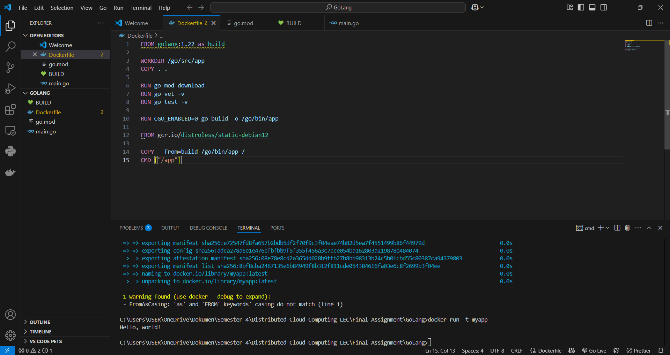

Bukti SS Docker (setelah di push ke docker):

